**Creating Cloud Accounts and Understanding Free plans**

* Azure Free tier:
  + Free Plan:  
    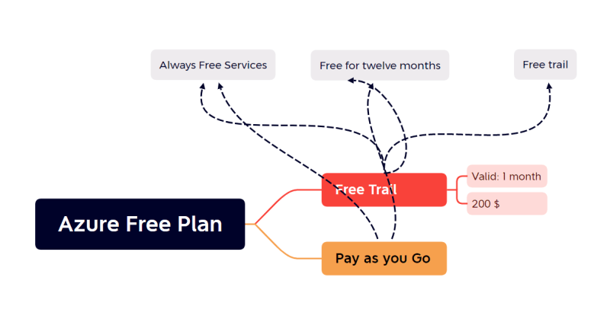
  + How to create: <https://azure.microsoft.com/en-us/free/> for the link
  + Best Practices:
    - Create a microsoft account <https://outlook.live.com/owa/> first
    - Use this account for creating free tier
    - Azure accepts
      * Credit cards (in india)
      * Some Visa/MasterCard debit cards are also accepted
      * net banking: ensure international transfers are enabled.
* AWS Free tier:
  + Free tier: <https://aws.amazon.com/free/>   
    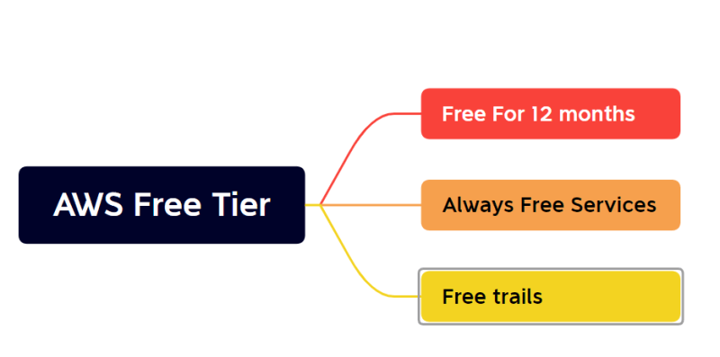
  + AWS Account can be created by using debit as well credit cards
  + Visa/MasterCard cards are only accepted
  + net banking: ensure international transfers are enabled.

**System Basics**

**Operating System**

* OS abstracts the complexity of devices and gives us an interface to communicate with system.
* Interfaces are of two types
  + Command line interfaces
  + Graphical user interfaces (GUI)
* Popular Operating Systems:
  + Windows
  + Linux
  + Mac (Osx)
* Generally we have server operating systems as well as Desktop (PC) Operating Systems
* 95% of Servers run linux operating systems

**Linux Operating Systems**

* Linux Hardware –> Shell –> Applications/Commands  
  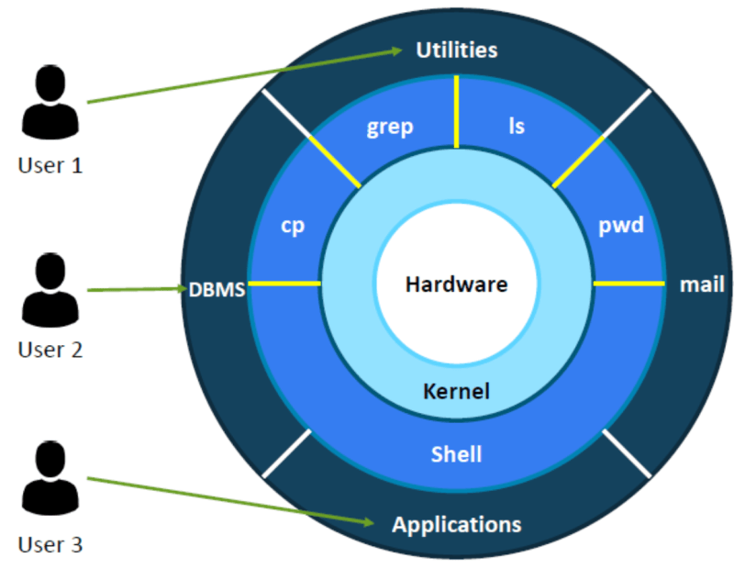
* When we speak about linux, we come across
  + RedHat
  + Ubuntu
  + Debian
  + SUSE
  + KALI
* The above names are referrred as distributions.
* On OS’s we run applications.
* Operating Systems Execute Process.
* Every process gets some cpu cycles and memory
* Linux Processes: Linux Processes can be created in two ways
  + FORK
  + EXEC